

***Saints Peter and Paul***

***Religious Ed and SWAG***

***This Friday***

***September 12th***

***6:30-9:00pm***

*Our first feature will be:*

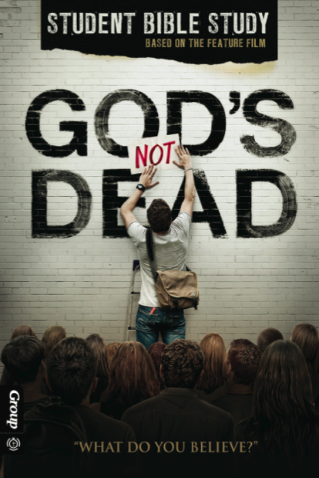

*Join us for pizza and a movie*

*Followed with*

*open discussion*

*about the film*

**

*September 12*

*God's Not Dead*

*October 17*

*Opera Night - Carmen*

*October 24*

*Heaven is For Real*

*November 14*

*WWJD*

*December 19*

*The Nativity Story*

*January 09*

*Finding Faith*

*February 13*

*Opera Night - The Mikado*

*February 20*

*In The Name Of God*

*March 13*

*Son of God*

*April 10*

*Touched By Grace*